

Lecture with Computer Exercises:

Modelling and Simulating Social Systems with Python

Project Report

|  |
| --- |
| Implementation of a Traffic Light System  at the Tannenbar-Intersection |

Nico Burger, Leo Fent, Jérôme Landtwig & Pascal Lieberherr

Zürich,  
 December 2018

Agreement for free download

We hereby agree to make our source code for this project freely available for download from the web pages of the SOMS chair. Furthermore, we assure that all source code is written by ourselves and is not violating any copyright restrictions.

|  |  |  |  |
| --- | --- | --- | --- |
|  |  |  |  |
| Nico Burger | Leo Fent | Jérôme Landtwig | Pascal Lieberherr |

Declaration of Originality



Table of Contents

1. Abstract 5

2. Individual contributions 6

3. Motivation 7

3.1 Fundamental Questions 7

3.2 Expected Results 7

4. Description of the Model 8

4.1 Matrix 8

4.2 Paths 9

4.3 Agents 10

4.4 Interaction between Agents 11

4.5 Iteration Speed 11

4.6 Traffic lights 11

4.7 Graphical Output 11

5. Implementation 13

5.1 Matrix 13

5.2 Paths 13

5.3 Agents 13

5.3.1 Agent Move 13

5.3.2 Agent Speed 14

5.3.3 Agent Spawning 14

5.4 Interaction between Agents 15

5.5 Traffic Lights 15

5.6 Graphical Output 15

5.6.1 Background and Agents 15

5.6.2 Traffic Lights 16

5.6.3 Waiting Pedestrians 16

5.6.4 Elapsed Time Display 16

6. Performed simulations 17

6.1 Timepoints 17

6.1.1 Scenario 1 17

6.1.2 Scenario 2 17

6.1.3 Scenario 3 17

6.1.4 Scenario 4 18

6.2 Traffic Light Periods 18

6.3 Simulation Numeration 18

7. Simulation Results and Discussion 19

7.1 Scenario 1: 19

7.2 Scenario 2: 20

7.3 Scenario 3: 21

7.4 Scenario 4: 23

7.5 Summary and Outlook 24

8. References 26

A. Additional Graphs 27

B. Python source Code 31

# Abstract

Authors: Nico Burger, Leo Fent, Jérôme Landtwig, Pascal Lieberherr

Title: Implementation of a Traffic Light System at the Tannenbar-Intersection

In this project we want to have a closer look at the intersection between the Tannenstrasse and Universitätsstrasse, also known as the Tannenbar-Intersection. We were motivated by our own experiences. During lecture breaks, early in the morning and at noon a lot of students want to cross the street. While pedestrians just keep crossing the street, cars start to line up. As a consequence, congestion and traffic holdups can be observed. Due to this situation, we asked ourselves whether traffic lights might reduce the waiting time for cars. At the same time the waiting time for pedestrians should not be too high. To do this, we simulated pedestrians, cars and trams with agents who behave according to the Swiss traffic rules. The whole simulation was done in Python.

To find out in which scenarios traffic lights make sense, we ran different simulations where we changed the car and pedestrian density from high to low. Furthermore, we figured out the best green/red time configuration of the traffic lights.

Finally, we arrived at the following conclusions: Traffic lights only show an improvement in traffic flow when car and pedestrian density are set to high. In this case the best green/red time configuration is 15 seconds waiting time for pedestrians and 25 seconds waiting time for cars. In all other cases, meaning when the density parameter was not set to high for both agents, traffic lights did not show any improvement compared to the simulation without traffic lights.

This document and all mentioned data can be downloaded from <https://github.com/jerowing/gess_project> (09.12.2018)

# Individual contributions

Nico Burger: path of agents and agent interaction, project report

Leo Fent: map, visualization, coordination, project report

Jérôme Landtwig: visualization, graphics and plots, project report

Pascal Lieberherr: path of agents, spawning of agents, project report, flash talk

Listed above are only the main tasks every one of us took care of, but we shared most of the work. The GitHub commit report is not always mirroring the work behind those uploads because we often worked together on the code, debugged, commented and worked on the documentation while swapping laptops.

# Motivation

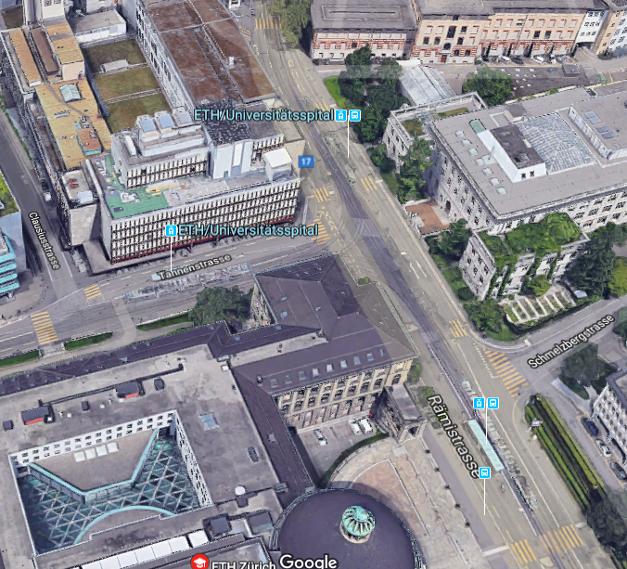

Figure 1: Birds eye view of the Tannenbar intersection.  
(Source: Google Maps)

The intersection between the Tannenstrasse and the Universitätsstrasse is something all ETH students are well familiar with and so are we. It is located in a traffic hotspot with pedestrians, cars and trams. All of those use the road simultaneously. This leads to conflict, especially at peak times. Since we cross this Intersection close to every day we started to think about how the occurring traffic jam during peak times could be reduced. Lecture breaks, afternoon and noon are considered as peak time. What crossed our minds was a traffic light system that controls the flow of the agents (pedestrians, cars and trams). This course offers the perfect opportunity to simulate the Tannenbar-Intersection with a traffic light system. During our observations of the crosswalk, we observed special dynamics e.g. cars that hardly stop for pedestrians waiting at the crosswalk as well as cars stopping way too early for pedestrians. Additionally pedestrians who insist on their right of way in every situation could be observed. Based on these experiences we became curios about the effects of a traffic light system controlling the agents.

## Fundamental Questions

We posed three guiding questions for our idea:

*How good is the current solution?* As described earlier, large traffic jams can be observed during peak times. Is this necessary for smooth pedestrian flow? What would change if pedestrians stopped once in a while to let cars pass?

*Could the situation be improved by adding traffic lights?* Traffic lights would force either the cars or the pedestrians to let the opposite party pass. How would that affect car waiting time? How much longer would pedestrians have to wait?

*What would be the best possible solution for all agents?* Is there an ideal solution (e.g. using traffic lights only at peak times)? What would it look like?

## Expected Results

To answer our three fundamental questions, we ran different simulations. Each simulation represents a certain time during the day with appropriate car and pedestrian densities. Each simulation was performed with and without traffic lights. Furthermore, we also varied the green time for both agents. This way we could compare the current situation, without traffic lights, with the newly implemented traffic light system. We expected the following different results for each scenario:

**Scenario 1:** Since we had high density for both cars and pedestrians, we expected an improvement in flow for cars when traffic lights are on while pedestrians would face an increased waiting time. Nevertheless, we expected an overall improvement due to the fact that the waiting time for cars can be reduced significantly while pedestrians waiting time only increases slightly. To find the optimum we would also vary the green time for cars and pedestrians, respectively. We expected that the green time split up evenly between cars and pedestrians would lead to the best results.

**Scenario 2:** For low car and high pedestrian density we did not expect as clear a result as for high car and high pedestrian density. As we had a high car density it was still likely that cars started to line up. Hence, we thought that in this case traffic lights might be unnecessary, simply because they would not improve the smooth agents flow significantly but only increase the pedestrian waiting time.

**Scenario 3:** In this case we expected similar results as for scenario 2. Namely, the flow would not improve significantly while the pedestrian waiting time would increase. The only traffic light configuration that would make sense is one with more green time for the pedestrians

**Scenario 4**: Scenario 4 was expected to be an obvious case again. We assumed that traffic lights would be unnecessary since they do not affect the agent flow in any case because of low density for both cars and pedestrians.

|  |  |  |  |
| --- | --- | --- | --- |
| Scenario | Time of day | Car density | Pedestrian density |
| 1 | 08:00 | High | High |
| 2 | 12:00 | High | Low |
| 3 | 17:00 | Low | High |
| 4 | 20:00 | Low | Low |

Table 1: A Summary of the different scenarios. Each simulation will be performed twice, once with and once without traffic lights.

# Description of the Model

## Matrix

In order to keep track of where our agents are, we implemented a matrix (100x100) where each entry represents a field/box in our simulation. This matrix is adjusted whenever an agent makes a move, or the traffic lights switch their state.

We mainly used the matrix to regulate the interactions between our agents. However, it also came in handy for counting the number of agents in a queue.

The following notation was used for the matrix entries:

|  |  |
| --- | --- |
| 0 | Empty cell |
| 1 | Pedestrian |
| 2 | Car |
| 3 | Tram |
| 4 | Red Light (for pedestrians) |
| 5 | Green Light (for pedestrians) |

## Paths

In order to reduce the complexity of slanted paths, it seemed logical to simplify the problem by making the paths of the intersection strictly horizontal/vertical. Since we are only interested in the intersection (including the crosswalks) we extended the streets up to the boundaries of our matrix and did not care what happens before/after an agent enters our simulation.

With this in mind, we ended up with the following paths:

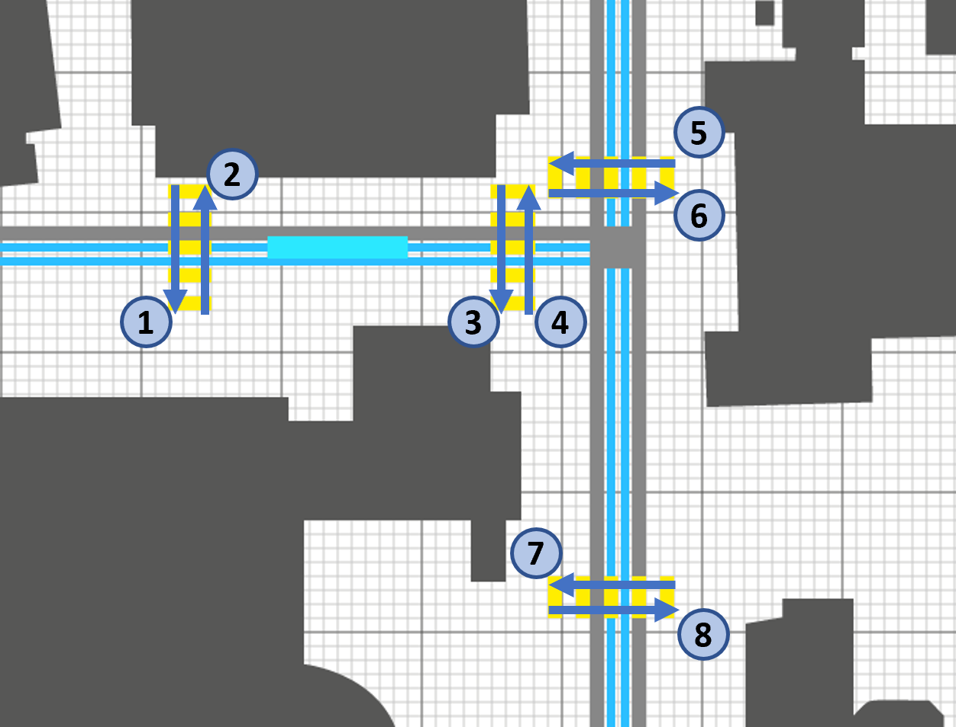

Figure 2: Pedestrian Paths

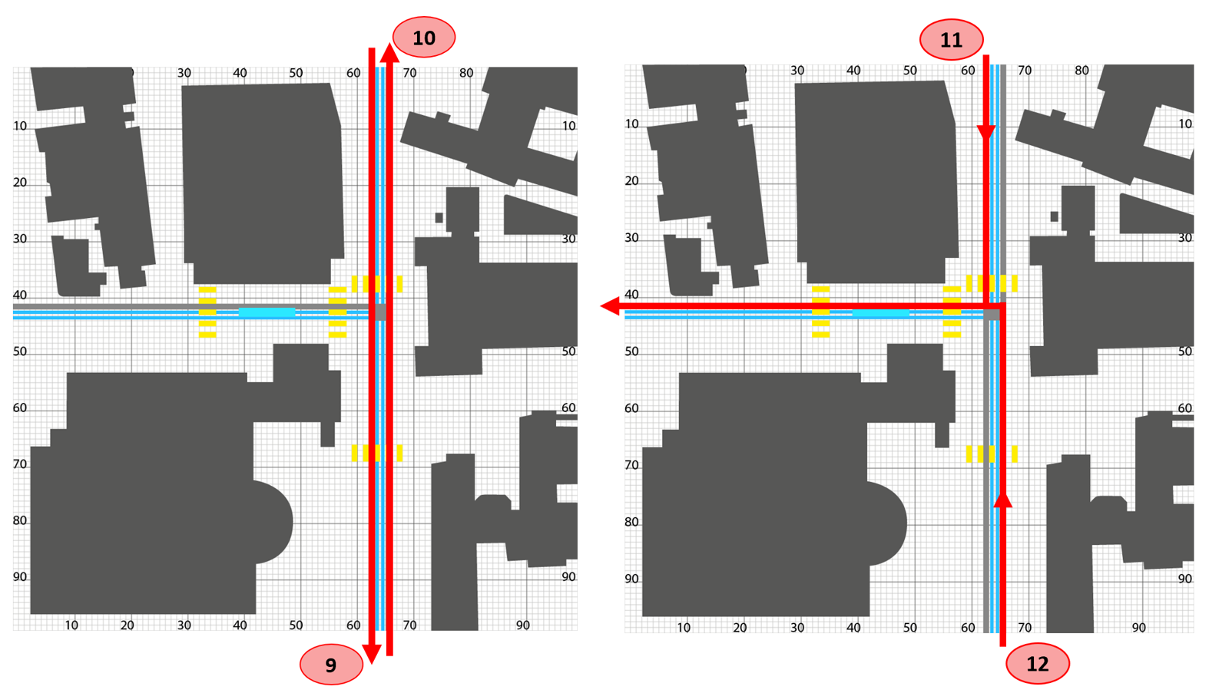

Figure 3: Car Paths

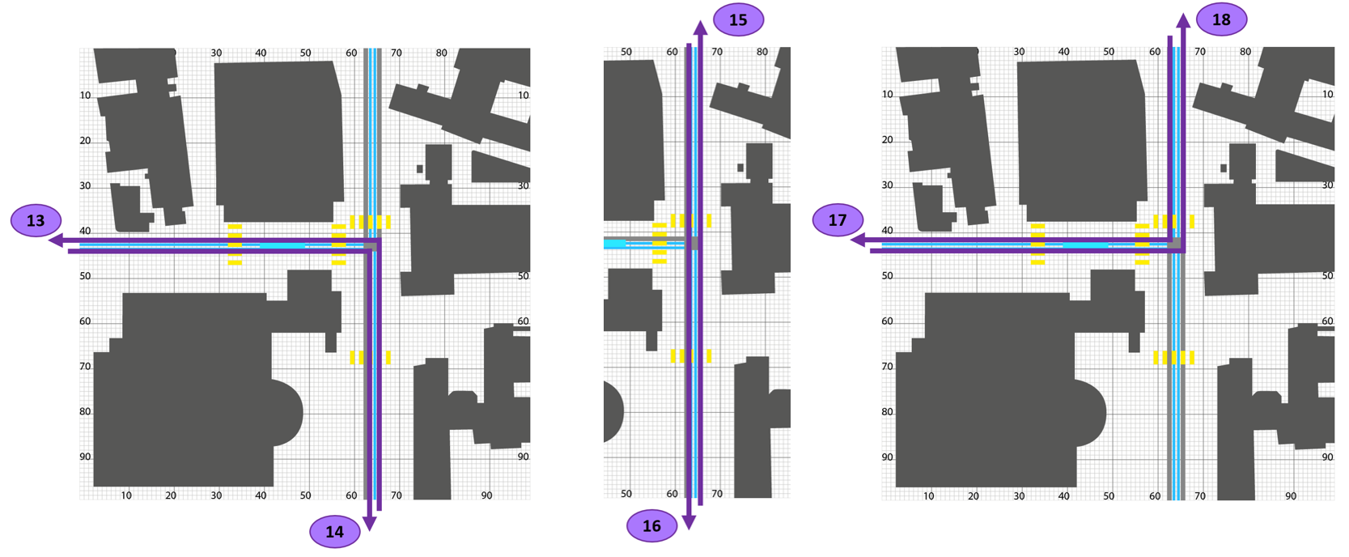

Figure 4: Tram Paths

In the Python code, the agent paths were labelled as follows:

|  |  |  |  |  |  |
| --- | --- | --- | --- | --- | --- |
| Nr. | Crosswalks (Figure 1) | Nr. | Streets (Figure 2) | Nr. | Tram-Path (Figure 3) |
| 1 | Crosswalk_L_L | 9 | Car_L | 13 | 6_Uni |
| 2 | Crosswalk_L_R | 10 | Car_R | 14 | 6_Polybah |
| 3 | Crosswalk_R_L | 11 | Car_L_L | 15 | 9_Uni |
| 4 | Crosswalk_R_R | 12 | Car_R_L | 16 | 9_Haldenbach |
| 5 | Crosswalk_U_U |  |  | 17 | 10_Haldenbach |
| 6 | Crosswalk_U_B |  |  | 18 | 10_Polybahn |
| 7 | Crosswalk_B_U |  |  |  |  |
| 8 | Crosswalk_B_B |  |  |  |  |

Table 2: Names of the paths in the code.

## Agents

Our simulation would theoretically depend on countless agents of varying importance and attributes. To simplify the problem, we narrowed it down to three agents: pedestrians, cars and trams. Therefore, we intentionally neglected all other potential agents which have a relatively small influence on the dynamics of the simulation (e.g. bicycles, ambulances). Simplifying the problem even more, we assumed that all agents of the same type have unified attributes (e.g. speed, size). This in turn reduced the accuracy of our model. In order to reduce this inaccuracy, we focused on finding unified attributes that represent the general behaviour of each agent.

By observing the Tannenbar-Intersection, we obtained the following generalizations for the speed of our agents:

* Pedestrian: 1 box / second
* Car: 6 boxes / second
* Tram: 3 boxes / second

Furthermore, we realized that for the simulation to be clear, pedestrians and cars should be of the same size, while trams are 8 times longer than a car. Therefore, pedestrians and cars have the size of a single block and trams of 8 consecutive blocks.

Lastly, we had to ensure that our agents got spawned randomly. We implemented this feature by giving every agent a probability to spawn on a certain path.

## Interaction between Agents

Because pedestrians, cars and trams should not collide, we needed to ensure that our agents follow a set of rules. Mirroring the real world, we came up with the following 4 rules:

1. Pedestrians only have to yield/give way to trams.
2. Trams must never give way.
3. Cars have to give way to pedestrians and trams.
4. If an agent wants to move to point (x, y), it is only allowed to do so if point (x, y) is not occupied by another agent.

We are aware that some people violate these rules however, to make our simulation applicable, we needed to assume that each agent follows the above rules.

## Iteration Speed

One iteration is to be understood as one cycle, during which all agents are updated to their new positions in the matrix. Because the minimal step for an agent in our simulation is one box, we had to set the iteration speed to the amount of time at which our slowest agent moves from one box to the next. Our slowest agents are the pedestrians, which move at a speed of one box per second (see 4.3). Therefore, one complete iteration of our simulation takes one second.

## Traffic lights

A central element of the simulation are the traffic lights which regulate whether the agents are allowed to continue on their path or have to stop. In order to simplify the model and due to time constraints we chose not to indulge in the complex topic of traffic planning and thus only to use two situations; one where all pedestrians have to wait and one where all cars have to wait whilst the pedestrians cross the street. Since we only have one street where cars pass and the crosswalks are relatively close together, we felt that this was a pretty good approximation of a real-life situation.

## Graphical Output

In order to get a better understanding of the agents' behaviour, we chose to output the movements of our agents to a map. Additionally, we feel that the graphical reference made coding easier and the simulation more realistic.

Starting with a map by the Federal Institute for Topography *swisstopo,* a simplified version was drawn and adapted for our uses.

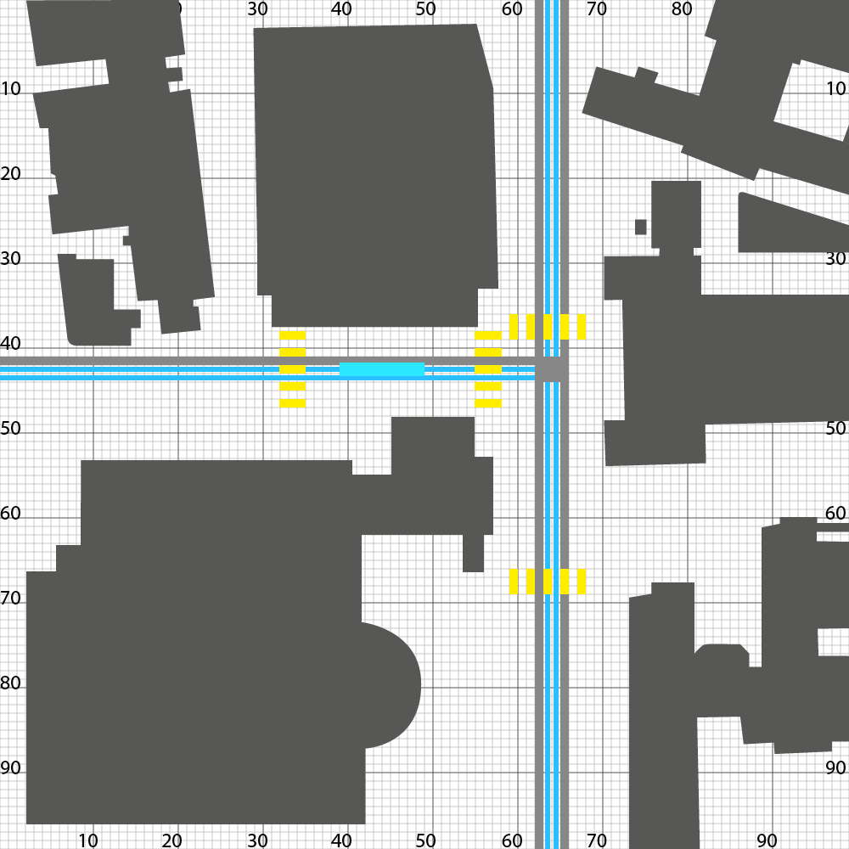 

Figure 5: The simplified map used in the Simulations (left) and the original map by swisstopo[1] (right).

The agents were then placed onto the map on the paths determined by the map. Finally, the traffic lights were added to have a visual representation of the agents having to stop.

# Implementation

## Matrix

In the program, the matrix is named “raster”. To initialize the matrix, we used a function called “initialize_gitter()”. Using the *numpy* library, the function creates a quadratic matrix (100x100) of type integer.

From then on, each iteration updates our matrix to contain information about the positions of our agents as well as the state of the traffic lights. This is achieved by plugging the matrix into all functions that update, either the positions of the agents or the states of the traffic lights.

## Paths

When an agent is spawned, it receives a pathname. Within the three different agent classes, there are dictionaries, which contain the start- and endpoints of the different paths. For example, in class Pedestrians:

self.startposx = {‘crosswalk_L_L’: 33, ‘crosswalk_L_R’: 35, ... }

self.startposy = {‘crosswalk_L_L’: 38, ‘crosswalk_L_R’: 48, ... }

self.endposy = {‘crosswalk_L_L’: 33, ‘crosswalk_L_R’: 35, ... }

self.endposy = {‘crosswalk_L_L’: 48, ‘crosswalk_L_R’: 38, ... }

The agent therefore knows where it starts and where it has to end up at. The function “speed(agent)” is called which returns the direction (x, y coordinates) which the agent must take to reach its endpoint. The direction is found in the agent’s class as “xspeed” and “yspeed”. For example, in class Pedestrians:

self.xspeed, self.yspeed = speed(self)

For paths which require a change in direction a midpoint is given. The agent sees this as it’s first endpoint. After reaching the midpoint, the agent’s endpoint gets updated to its final destination, the direction is changed, and it proceeds towards its endpoint. If an agent does not have require a midpoint, the midpoint in the dictionary is a string “no” (for “no” midpoint) and it skips the previously stated process of using a midpoint as an intermediate endpoint.

## Agents

The agents are stored in lists (walkers, drivers, tram). When a new agent is spawned, it’s address is added to the end of the list, from which it can be accessed. When an agent reaches its destination its address in the list gets deleted.

The “iterate” function is called by plugging in a list (walkers, drivers or tram). This function then updates the positions of all agents in that list, hence, it iterates through the list. The “iterate” function is not to be confused with a complete iteration which has been defined above.

### Agent Move

An agent makes a move, when it is called by the “move(agent, matrix)” function. This function checks which position the agent would like to move to and if that position is occupied already. If the position is occupied by another agent (entry != 0), it leaves everything the way it was before the function was called. Otherwise, the “move” function:

1. sets the old position of the agent in the matrix to 0
2. sets the new position of the agent in the matrix to either 1, 2 or 3 (depending on the agent type)
3. updates the agents coordinates to the new position
4. moves the window object of the agent to the new position

Another thing it checks, is whether the agent is at its endpoint. If that is the case, the function returns “True”, otherwise it returns “False”. This in turn is used during the “iterate” function, which deletes the agent if the “move” function returns “True”.

### Agent Speed

One iteration moves our slowest agents, the pedestrians, once per second. As stated, we wanted the trams to be three times faster and the cars to be six times faster than the pedestrians. Therefore, we called the “iterate” function of the trams/cars 3/6 times respectively during one iteration so that the “move” function is called 3/6 times for each tram/car during one iteration. This results in the trams/cars being 3/6 times as fast as pedestrians. We implemented this in the main function:

# iteration of all agents for each second

# car_speed = 6

iterate(walkers, raster)

i = 1

while i <= car_speed:

if i % 2:

iterate(tram, raster)

iterate(drivers, raster)

tk.update()

i += 1

### Agent Spawning

For each iteration, there should be a possibility for one or more new agents to be spawned at each path. We created two parameters to code and work with this prerequisite. These parameters are:

1. The chance of an agent being spawned at a given path (given in percent)
2. The number of possible agents being spawned at a given path

Since we analyze 4 different scenarios, we have a global variable (variante_zeiten) which sets the spawning frequencies of each path with the two mentioned parameters. These spawning frequencies are adjusted to the different scenarios. Hence, at 08:00 o’clock the probabilities for an agent to spawn are higher than at 20:00 o’clock.

Calling the “spawn” functions once per iteration leads to new agents being created and added to the lists (walkers, drivers, tram) just as planned.

## Interaction between Agents

In order to make our agents to follow the rules we initially set (see 4.3), we can use the order in which the “iterate” functions are called during one iteration to our advantage. By first iterating the pedestrians, second the trams and at last the cars, we achieve exactly this behavior. That is, because the matrix is updated after each iteration. Hence, if we first use the “iterate” function on the pedestrians, they will be the first to move.

The 4th rule is dealt with in the “move” function, which eliminates the possibility for an agent to move to a new position whilst another agent is occupying that position.

## Traffic Lights

In each cell of the above described 100x100 Matrix information can be found about whether the next position of the agent is occupied is free. If so, the agent can move on to the next position. In order to stop pedestrians and cars from running red lights, the function rotlicht() is used. rotlicht() has three different cases as inputs:

* rotlicht(1, matrix): All cells in front of the traffic lights are set to 0.
* rotlicht(2, matrix): The cells in front of the pedestrian crossings are set to 4. This means that pedestrians recognize an "obstacle" in front of them and thus wait.
* rotlicht(3, matrix): The cells in front of the cars at the pedestrian crossings are set to 5. This in turn means that cars have to wait and pedestrians can cross.

## Graphical Output

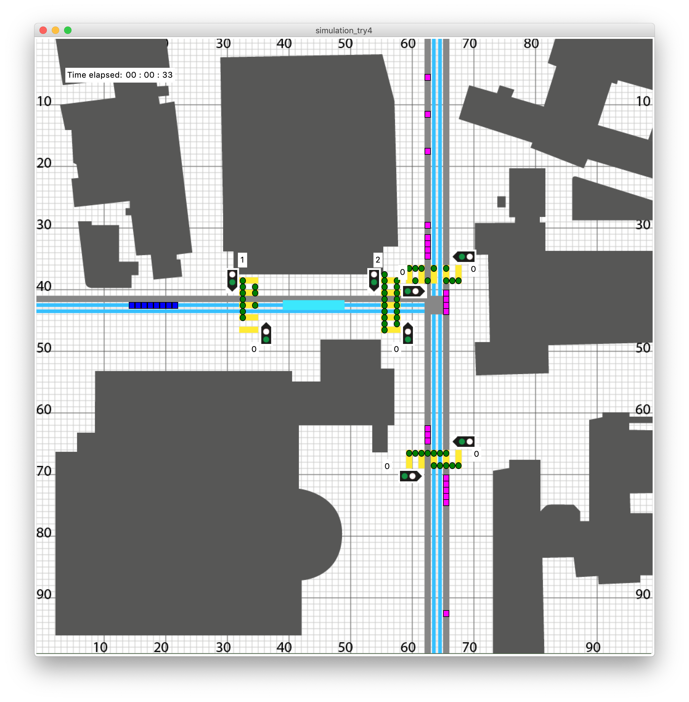

Figure 6: A running simulation.

### Background and Agents

The graphical output was achieved using Python's *tkinter* module[2]. The above described map (Figure 4) was first drawn in Adobe Illustrator and then exported as gif. This made it possible to use it as a background for the tkinter window (later called canvas). On the canvas, the agents were placed using the tkinter functions .create_oval and .create_rectangle. These functions are called each time an agent is moved using the move() or move_tram() function.

### Traffic Lights

The traffic lights were again drawn as gifs in Adobe Illustrator and then placed as a label onto the canvas. In order to keep the graphical output as clean as possible, it was decided to only have traffic lights for pedestrians. For each crosswalk, when the pedestrians are allowed to walk, the lights change to green, which in turn means that cars have to wait.

### Waiting Pedestrians

In order to quantify the amount of waiting the pedestrians have to do, we chose to count, how many pedestrians were stationary at their initial position. When calling the move() function, the amount of waiting pedestrians is updated for each crosswalk. The dictionary is then output to the canvas with the display_waiters() function.

The display_waiters() function takes the dictionary as an input and the places labels at the corresponding places on the canvas.

### Elapsed Time Display

For the viewer to have a feeling of the speed of the simulation, we implemented a label which displays the amount of time passed. For ease of simulation and graphing, time is tracked by the global variable i of the main for loop. However, to display Time, three variables t_s, t_min and t_h are used which then get placed onto the canvas using the function print_time().

# Performed simulations

We wanted to analyze the impact of different traffic lights on our modeled system of the intersection. As the amount of pedestrians and of course the density of car drivers passing the intersection vary during the time of a day we chose to make measurements at four different times to get a birds eye view how good a version of a traffic light is in general. We chose the following generic timepoints:

## Timepoints

### Scenario 1

We chose the timepoint 8'o'clock as an example with a high pedestrian density and a high car density as well. This means that we set the chances of spawning pedestrians and cars higher than in low density cases. This is matches the reality pretty well as most of the students attend lectures that start at 8:15 and a lot of workman commute to work at this time. For this simulation we chose the following parameters.

# 08:00 [Chance, Amount] of Pedestrians/Cars spawned (per second)

amount_ped = {'crosswalk_L_L': [60, 1], 'crosswalk_L_R': [20, 1],

'crosswalk_M_L': [60, 1], 'crosswalk_M_R': [20, 1], 'crosswalk_U_U': [60, 1],

'crosswalk_U_B': [20, 1], 'crosswalk_B_U': [60, 1], 'crosswalk_B_B': [20, 1]}

amount_car = {'car_L': [60, 1], 'car_R': [60, 1]}

### Scenario 2

Around lunchtime. Loads of students leave their lectures and walk to a nearby mensa. Most of the workman stay at their institution which means that the density of cars passing our system is rather small.

# 12:00 [Chance, Amount] of Pedestrians/Cars spawned (per second)

amount_ped = {'crosswalk_L_L': [20, 1], 'crosswalk_L_R': [60, 1],

'crosswalk_M_L': [20, 1], 'crosswalk_M_R': [60, 1], 'crosswalk_U_U': [20, 1],

'crosswalk_U_B': [60, 1], 'crosswalk_B_U': [20, 1], 'crosswalk_B_B': [60, 1]}

amount_car = {'car_L': [30, 1], 'car_R': [30, 1]}

### Scenario 3

Not all students leave university at the same time. Some lecture finish earlier than others. Some students stay at university and keep studying on their own. Resulting in a low pedestrian density. All the workman that commuted to work in the morning leave work around this time and drive back home. Ending up with a high car-density.

# 17:00 [Chance, Amount] of Pedestrians/Cars spawned (per second)

amount_ped = {'crosswalk_L_L': [20, 1], 'crosswalk_L_R': [20, 1],

'crosswalk_M_L': [20, 1], 'crosswalk_M_R': [20, 1], 'crosswalk_U_U': [20, 1],

'crosswalk_U_B': [20, 1], 'crosswalk_B_U': [20, 1], 'crosswalk_B_B': [20, 1]}

amount_car = {'car_L': [60, 1], 'car_R': [60, 1]}

### Scenario 4

In the evening there isn't much traffic around our intersection. There are neither much students around nor much cars passing our intersection. Resulting in low pedestrian density and low car density

# 20:00 [Chance, Amount] of Pedestrians/Cars spawned (per second)

amount_ped = {'crosswalk_L_L': [20, 1], 'crosswalk_L_R': [20, 1],

'crosswalk_M_L': [20, 1], 'crosswalk_M_R': [20, 1], 'crosswalk_U_U': [20, 1],

'crosswalk_U_B': [20, 1], 'crosswalk_B_U': [20, 1], 'crosswalk_B_B': [20, 1]}

amount_car = {'car_L': [30, 1], 'car_R': [30, 1]}

In summary, the different scenarios look like this:

|  |  |  |  |
| --- | --- | --- | --- |
| Scenario | Time of day | Car density | Pedestrian density |
| 1 | 08:00 | High | High |
| 2 | 12:00 | High | Low |
| 3 | 17:00 | Low | High |
| 4 | 20:00 | Low | Low |

Table 3: A Summary of the different scenarios.

## Traffic Light Periods

For each scenario we decided to analyse four different traffic light waiting periods (**T**raffic **L**ight scenario). The values were chosen based on observations around Zürich.

|  |  |  |
| --- | --- | --- |
|  | Pedestrian waiting time [s] | Car waiting time [s] |
| TL scenario 1 | 0 (no traffic lights) | 0 (no traffic lights) |
| TL scenario 2 | 15 | 25 |
| TL scenario 3 | 20 | 20 |
| TL scenario 4 | 25 | 15 |

Table 4: Traffic light period times for different scenarios.

## Simulation Numeration

For a better overview we decided to number the simulation scenarios as follows

|  |  |  |  |  |
| --- | --- | --- | --- | --- |
| Simulation nr. | TL scenario 1 | TL scenario 2 | TL scenario 3 | TL scenario 4 |
| Scenario 1 | 1.1 | 1.2 | 1.3 | 1.4 |
| Scenario 2 | 2.1 | 2.2 | 2.3 | 2.4 |
| Scenario 3 | 3.1 | 3.2 | 3.3 | 3.4 |
| Scenario 4 | 4.1 | 4.2 | 4.3 | 4.4 |

Table 5: Numeration of the simulation scenarios.

# Simulation Results and Discussion

## Scenario 1:

In the first scenario we simulated a high/high pairing, meaning both the pedestrian and car density were high. Depending on the traffic light period we got very different results. In scenario 1.1 (no traffic lights, Figure 6) we got a deadlock in our system. This meant that neither the pedestrians nor the cars were able to advance any more. Obviously, this would not happen in the real world and we see this as a failure of our model. Nonetheless Scenario 1.1 mirrors our experience in the real world, where the cars cannot move any more due to the number of people wanting to cross the street. That's where, in real life, the "rule breakers" come in. We did not simulate pedestrians who wait for cars to cross or cars that push their way through pedestrians. Either of them would have a significant effect on the simulation.

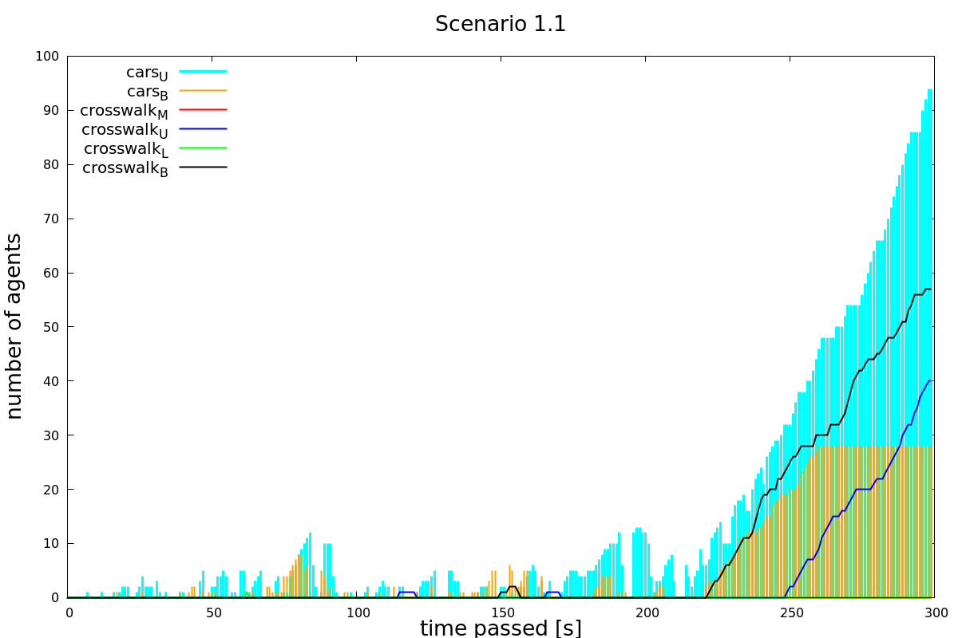

Figure 7: Scenario 1.1: High pedestrian and car density as well as no traffic lights.

We did see, however, a significant increase in the fluidity of traffic in scenario 1.2 (15s pedestrian waiting time, 25s car waiting time, Figure 7). As can be seen in the graph, the peaks of waiting pedestrians and cars reduce to zero after each period. Only exception is crosswalkU where we can see a build-up of waiting pedestrians after roughly 200 seconds. Note however, that the maximum number of people having to wait is five. In real life, that would pose no problem since people are able to walk in larger groups over the pedestrian crossing. Thus the last five people would be able to cross as well.

In scenario 1.2 and 1.3 the build-up of pedestrians and cars waiting was considerably more significant (see table **NUMBER** in Appendix A).

Taking that into account, we feel that scenario 1.2 is a good solution to traffic jams occurring when there are lots of pedestrians as well as lots of cars. Other traffic lights periods did not prove to have a positive effect on traffic flow.

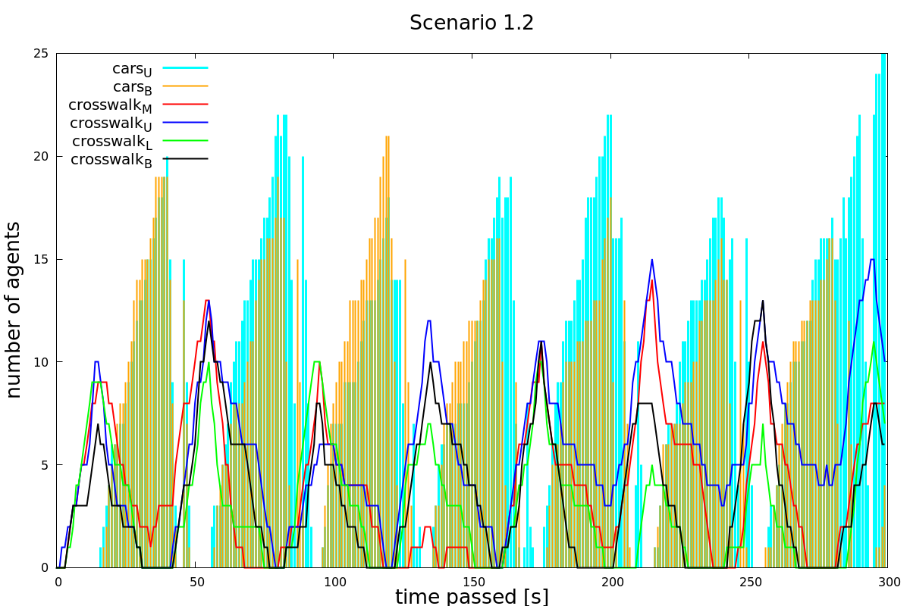

Figure 8: Scenario 1.2: High pedestrian and car density, traffic light period nr. 2.

## Scenario 2:

In scenario 2, high car density along with a low pedestrian density was simulated. In Figure 8 it can clearly be seen that traffic flows very well. Even though the peaks of cars having to wait build up very quickly, they do not grow very tall. The rapid build-up (steep slope) of the peaks can be explained by the high number of cars arriving at a pedestrian crossing. The waiting times for cars remain short however, due to the number of pedestrians being rather small.

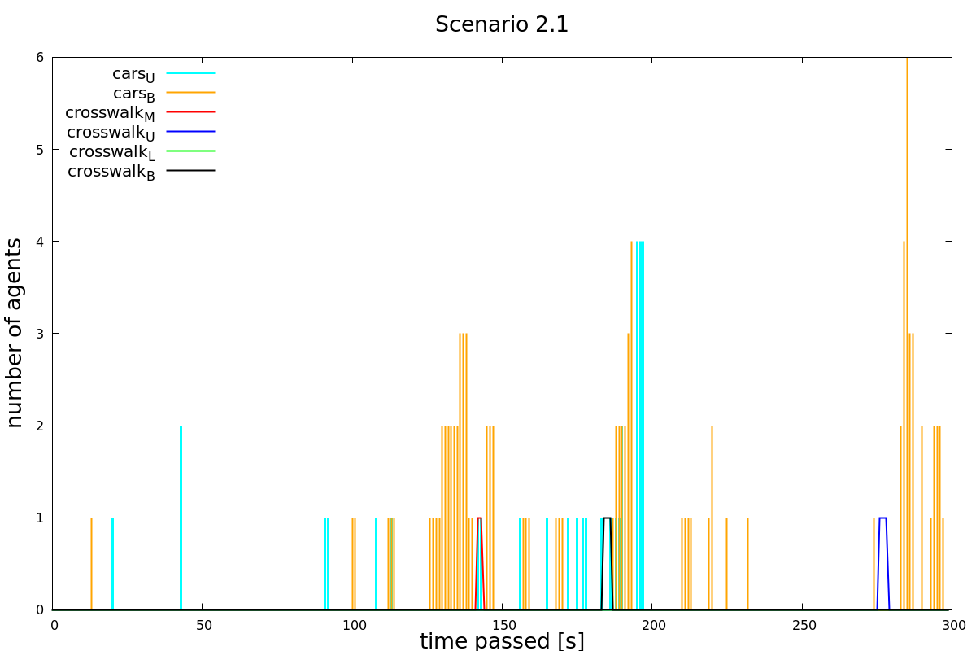

Figure 9: Simulation 2.1: High car and low pedestrian density, no traffic lights.

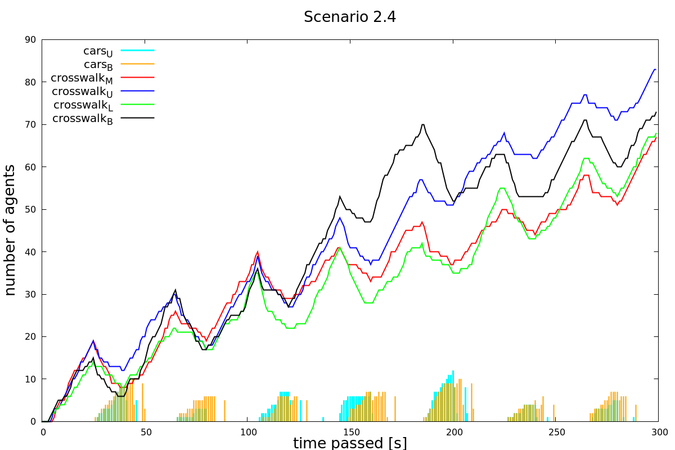

Figure 10: Scenario 2.4: High car and low pedestrian density, pedestrian waiting time 25s.

Figure 9 shows a wildly different picture. Even though there are relatively few pedestrians, them having to wait for 25 seconds leads to a massive and linearly increasing build-up of pedestrians at the crossings. Shorter waiting times (see scenarios 2.2 and 2.3 in the appendix) show a similar phenomenon although less dramatic.

This leads us to the conclusion that traffic lights do not have a positive effect on traffic flow when only few pedestrians are present. In the real world, we have made similar observations. When there are only few pedestrians, the cars have to wait only for short amounts of time which results in a steady traffic flow even when car density is high.

## Scenario 3:

In scenario 3 the parameter car density was set to “low” and the pedestrian density to “high”. Looking at Figure 11 (no traffic lights) leads us to the conclusion that the flow of the agents is guaranteed without traffic lights. Due to the fact, that pedestrians never had to wait and only very few cars had to stop at the crossroad. The average of waiting cars is approximately 1.5. This exactly fulfils our requirements: As little as possible waiting time for pedestrians and only short waiting times for cars.

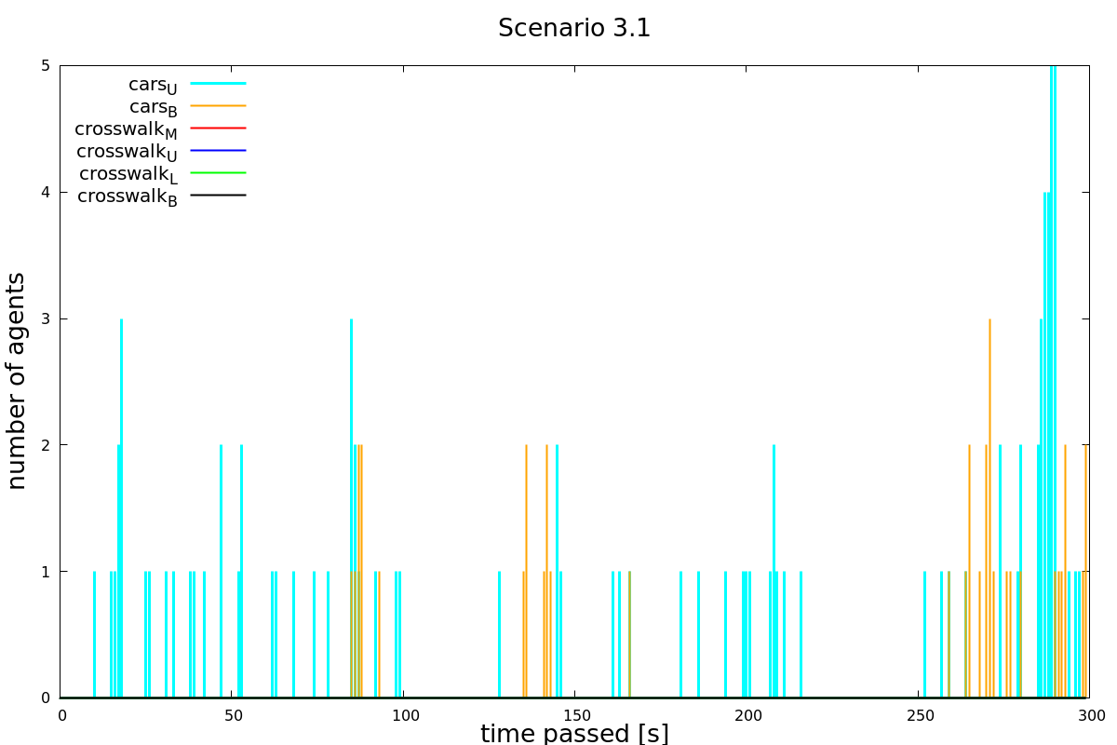

Figure 11: Scenario 3.1: Low car density, high pedestrian density, no traffic lights.

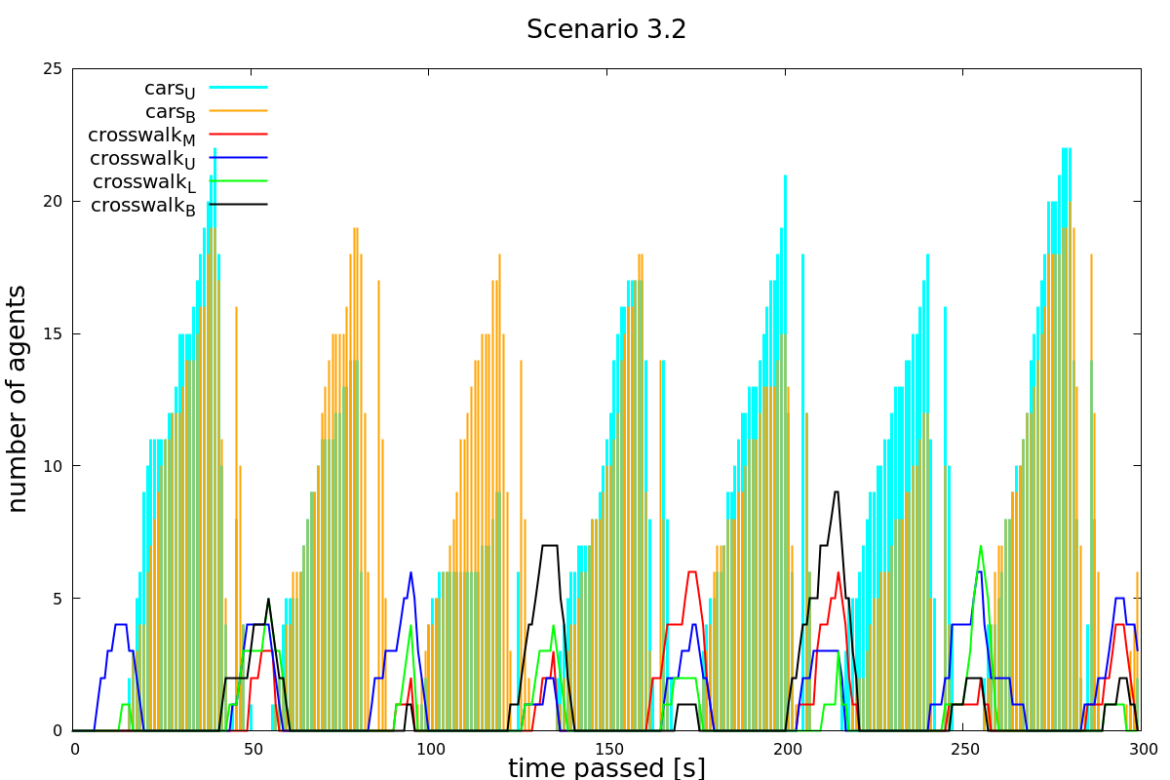

Figure 12: Scenario 3.2: low car and high pedestrian density. Waiting time for pedestrians 15s, for cars 25s.

Figure 12 (waiting time pedestrians 15s, waiting time cars 25s) shows approximately a maximum of 17 cars waiting while the traffic light is on red. The number of waiting pedestrians is around three to six. On the one hand, this is actually not an improvement compared to scenario 3.1 (no traffic lights) since there were no pedestrians waiting to cross the street. On the other hand, it is possible for both agents to either cross the street or the crosswalk when their traffic light shows green. Therefore, the traffic light does not cause any traffic jam. Nevertheless, in our case, traffic lights don’t make sense since they increase waiting time for both cars and pedestrians. The only reason why it could make sense in this case is when further aspects as safety are taken into account. However, this is not part of our thesis. The diagrams of scenarios 3.3 and 3.4 depict a similar situation as we have in diagram 3.2. Diagrams of scenarios 3.3 and 3.4 can be found in the appendix.

## Scenario 4:

Scenario 4 with parameters low car and low pedestrian density shows a very similar behavior as the plots of scenario 3. Namely, the flow is ensured without traffic lights (see Figure 13) since we cannot observe any waiting pedestrians and only once in while a car that has to stop at the crossroad. Thus, in this situation there is no need for traffic lights.

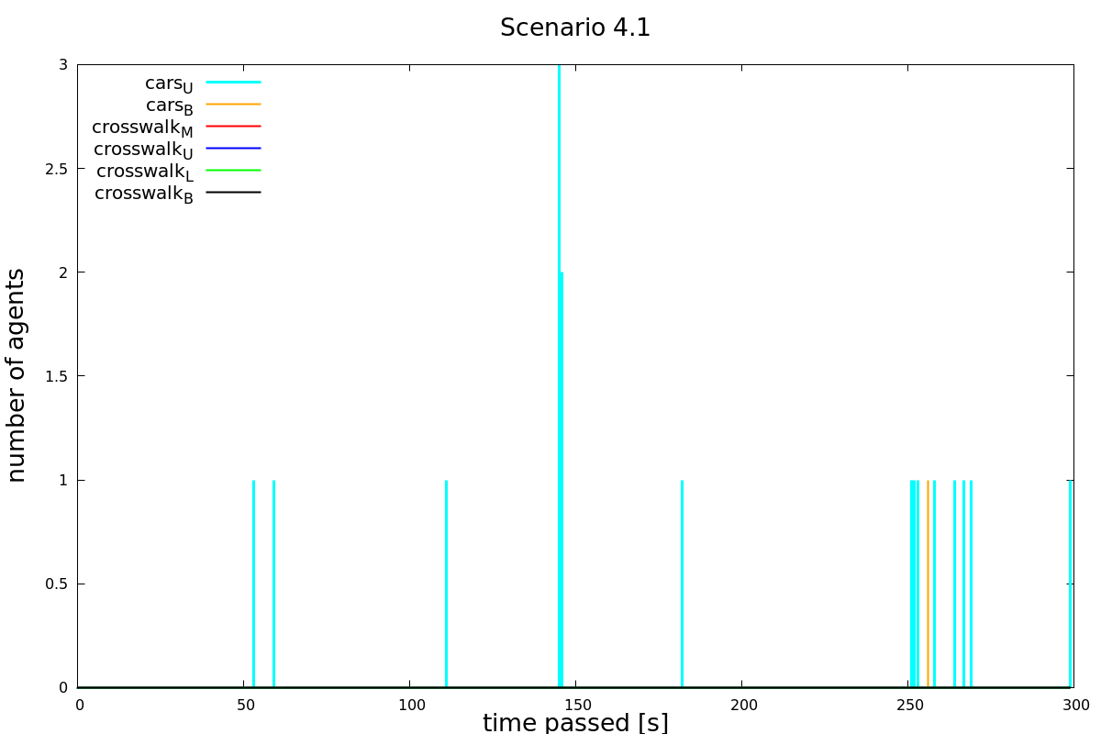

Figure 13: Scenario 4.1: low car and pedestrian density, no traffic lights.

Having a look at scenario 4.3 where the green time between pedestrians and cars is equally split up leads us to a similar conclusion as for scenario 3.2. It is actually not an improvement compared to scenario 4.1 since there occurred no waiting pedestrians whereas pedestrians have to wait in scenario 4.3. As a result, implementing traffic lights worsens the situation for both cars and pedestrians. Scenario 4.2 and 4.4 are similar to scenario 4.3 and can be found in the appendix.

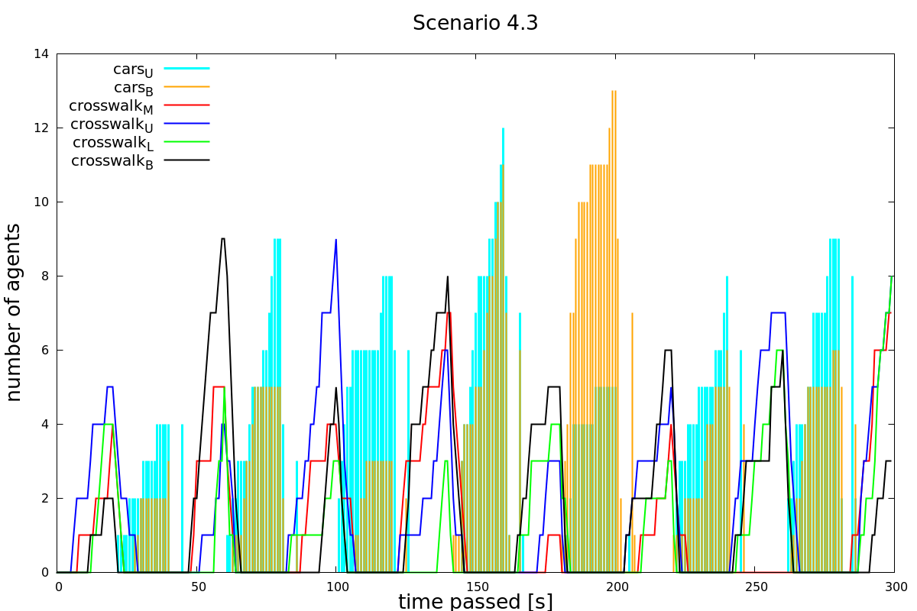

Figure 14: Scenario 4.3: Low car and pedestrian density. Waiting time 20s for pedestrians, 20s for cars.

## Summary and Outlook

The aim of this project was to figure out whether the implementation of traffic lights at the Tannenbar Intersection leads to a significant reduction in waiting time for cars while the pedestrian waiting time only increases slightly. To answer this question, we ran four different simulations:

In scenario 1 we simulated a high/high pairing, meaning both the pedestrian and car density were high. In scenario 2 pedestrian density was set to low and car density to high and in scenario 3 pedestrian density was set to high and car density to low. Scenario 4 was simulated with a low/low pairing. Each scenario was simulated once without traffic lights and once with traffic lights. To find the best green/red time configuration for the traffic lights we also varied the green/red time for both agents (see Table 2).

Evaluating the diagrams of the different scenarios lead us to the following conclusion: Only in scenario 1 the traffic lights show a significant flow improvement compared to the situation without traffic lights. However, in this case our model shows its limitations since deadlocks occur. This means no agent was able to advance anymore. For further research this would be something that needs to be improved. We also figured out that the best green/red time configuration of the traffic lights is 15 seconds waiting time for the pedestrians and 25 seconds for the cars. This way the peaks of waiting pedestrians and cars reduces to zero each period. The scenarios 2,3 and 4 did not show any improvement with traffic lights. Either the peak of the waiting pedestrians did not reduce to zero each period and therefore linearly increased over time or the number of waiting pedestrians and cars was just smaller without traffic lights. Note that we only consider waiting time and no other aspects as for example safety. Taking other aspect such as safety reasons into account would be something that could be done in further research.

The following points listed below would make sense to improve when further research is done:

* Adapt the code such that no deadlocks can occur
* In general, it is worth to put effort in to a model that is closer to reality. For example, take the fact into account that cars slow down several meters before the crosswalk in case of a waiting pedestrian and also that they have a certain acceleration after they stopped. Furthermore, pedestrians tend to wait at the crosswalk until the car has slowed down only than they cross the street.
* To decide whether traffic lights make sense it is also worth to take other aspects into account such as safety reasons.

To sum up, it would only make sense to implement traffic lights when there are a lot of cars and many pedestrians. Furthermore, the best green/red time configuration would be 15seconds for waiting time for pedestrians and 25 for cars. In all other cases traffic lights do not show an improvement in traffic flow.

# References

Python Software Foundation. (2018). *24.1. Tkinter — Python interface to Tcl/Tk — Python 2.7.15 documentation*. Retrieved from https://docs.python.org/2/library/tkinter.html

swisstopo. (2018, 11 07). *Karten der Schweiz - Schweizerische Eidgenossenschaft - map.geo.admin.ch*. Retrieved from https://s.geo.admin.ch/7e18fb5b95

A. Additional Graphs

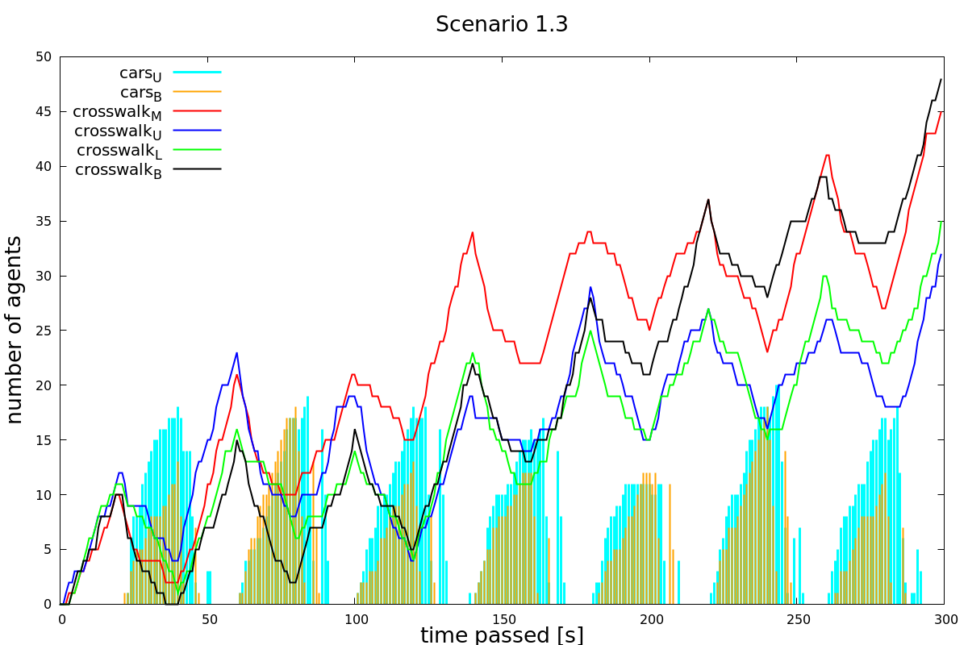

Figure 15: Scenario 1.3: High pedestrian and car density, pedestrian waiting time 20s, car waiting time 20s.

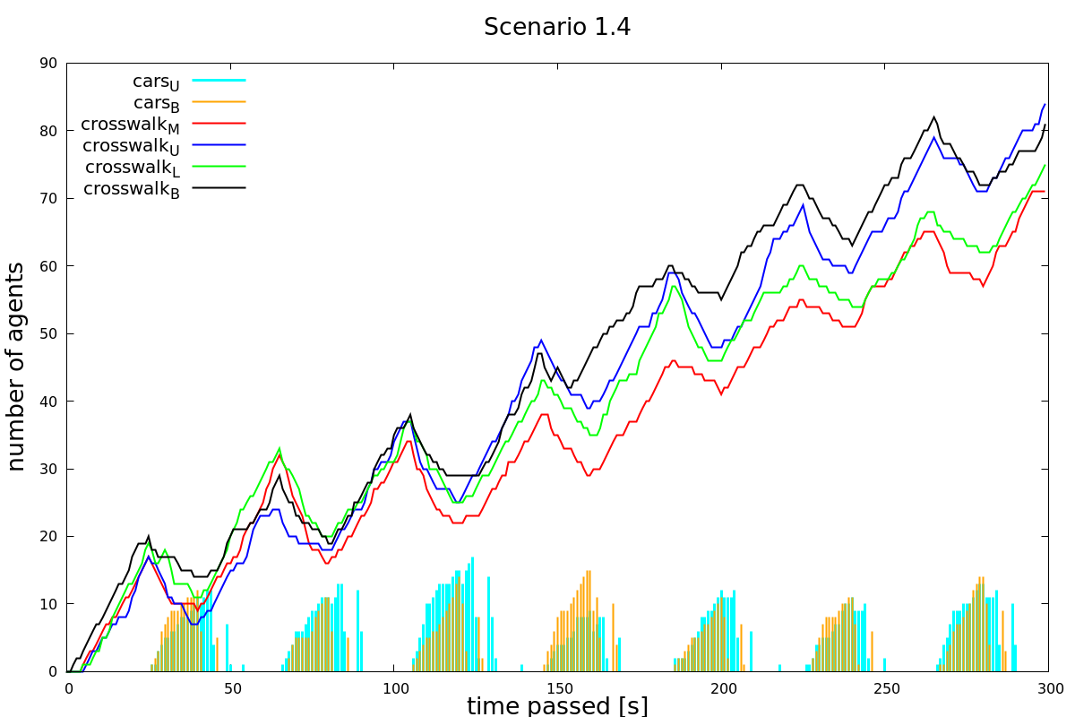

Figure 16: Scenario 1.4: High pedestrian and car density, pedestrian waiting time 25s, car waiting time 15s.

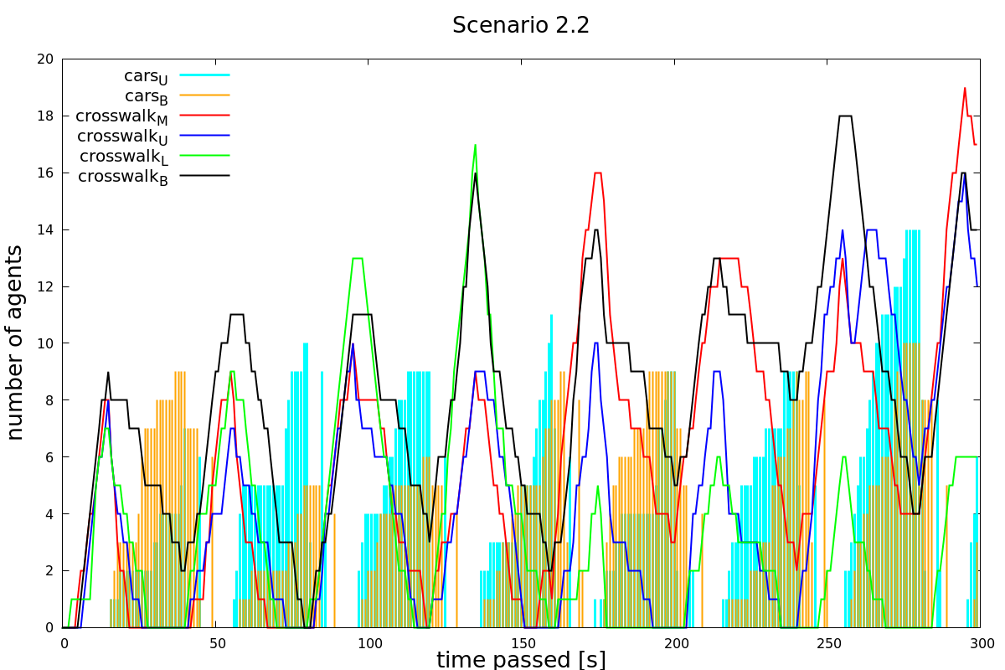

Figure 17: Scenario 2.2: Low pedestrian and high car density, pedestrian waiting time 15, car waiting time 25s.

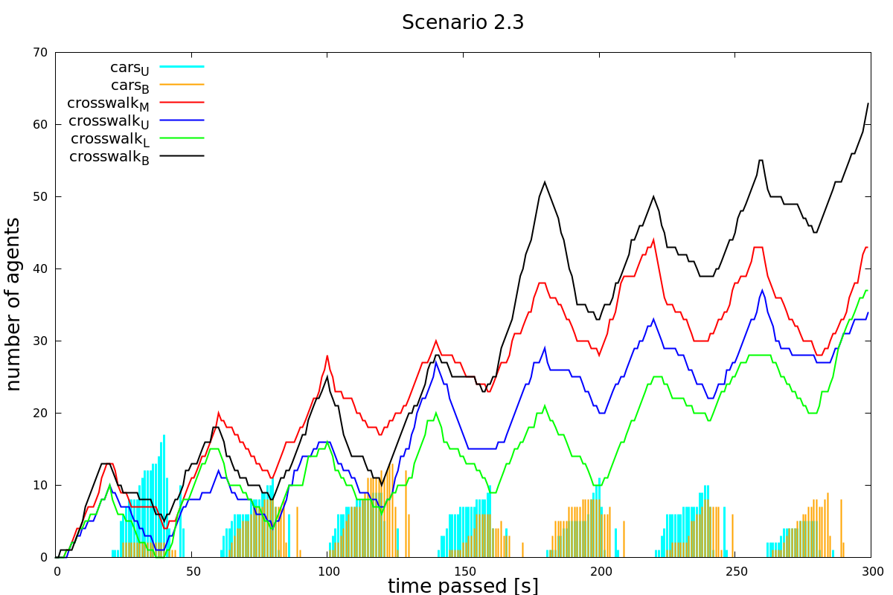

Figure 18: Scenario 2.3: Low pedestrian and high car density, pedestrian waiting time 20s, car waiting time 20s.

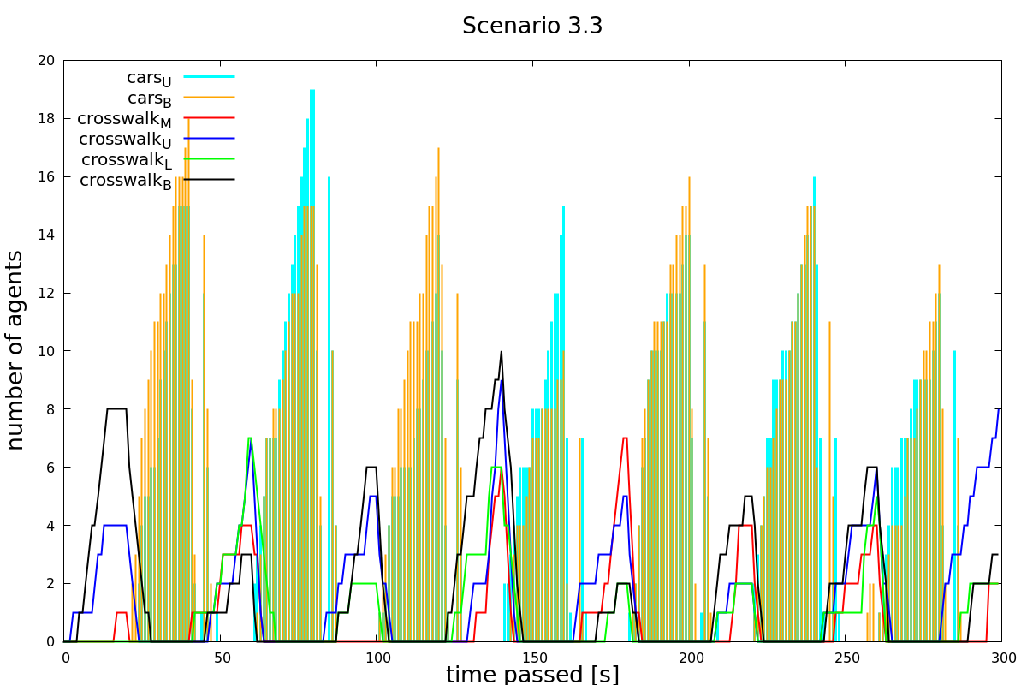

Figure 19: Scenario 3.3: High pedestrian and low car density, pedestrian waiting time 20s, car waiting time 20s.

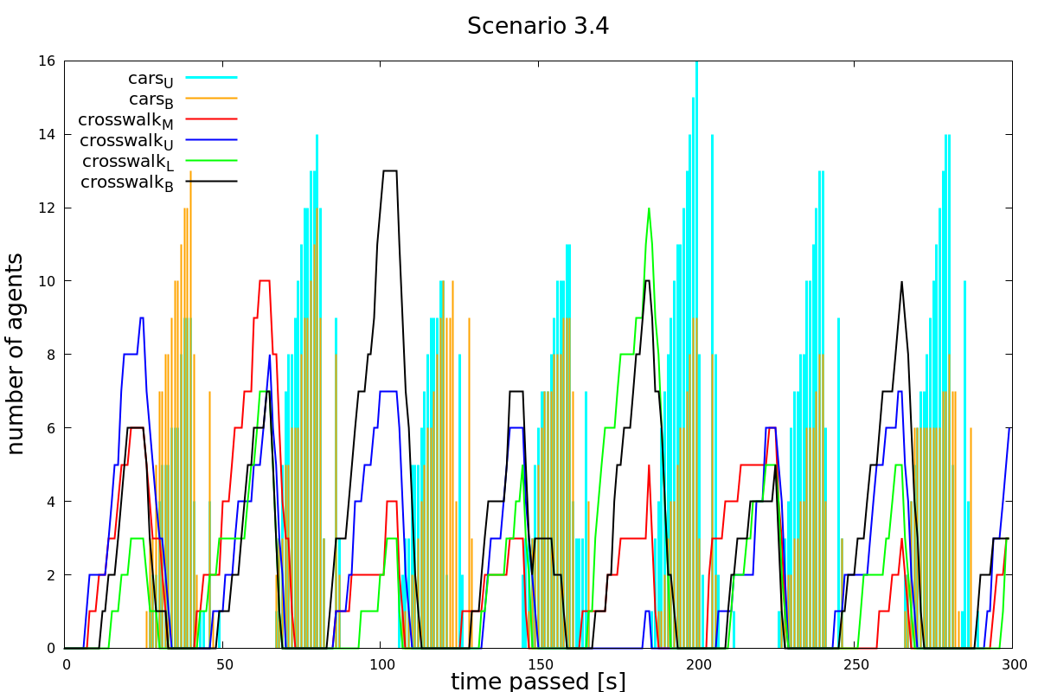

Figure 20: Scenario 3.4: High pedestrian and low car density, pedestrian waiting time 25s, car waiting time 15s.

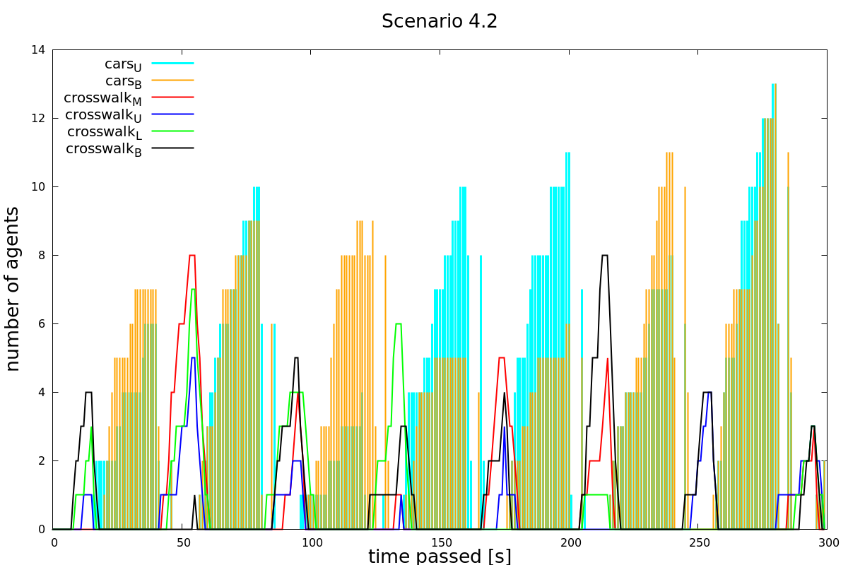

Figure 21: Scenario 4.2: Low pedestrian and car density, pedestrian waiting time 15s, car waiting time 25s.

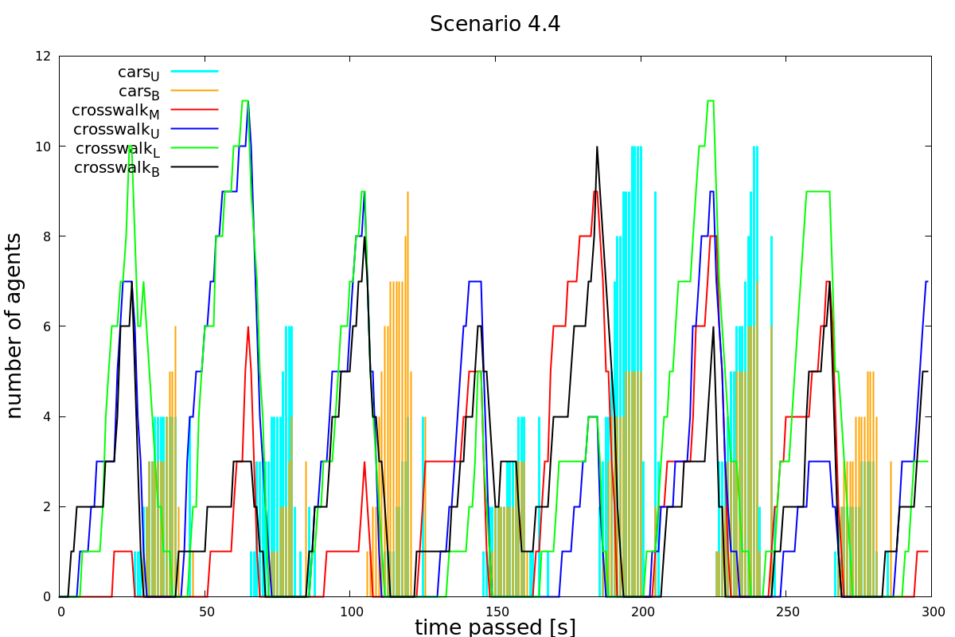

Figure 22: Scenario 4.4: Low pedestrian and car density, pedestrian waiting time 25s, car waiting time 15s.

B. Python source Code

Code goes here

1. (swisstopo, 2018)
2. (Python Software Foundation, 2018)